DS_lab task
Roll no : 2502477
M.SHAHMEER

Task 1

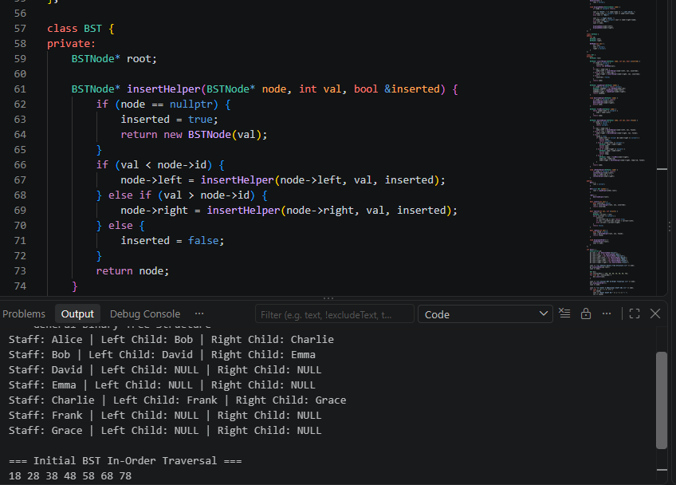

Task 2
